**Getting Started**

The following manual will guide you through your basic account setup.

* Netsuite.com – customer login
* Username: your umb email address
* Password: net123
* Set up your account
  + Change password to *Student360*, secret questions.
* Use Administrator as the role

**Don’ts**

* **NEVER select the roles of Vendor Center, Partner Center, or Employee Center, (Selecting these will lock them out of their accounts).**
* Don’t contact technical support
* Don’t change email addresses on accounts
* Don’t lose your password

# Setting Admin as the Default Role & Changing Company Name

After logging in for the 1st time your screen will look similar to this. There will be access to multiple roles within the company.

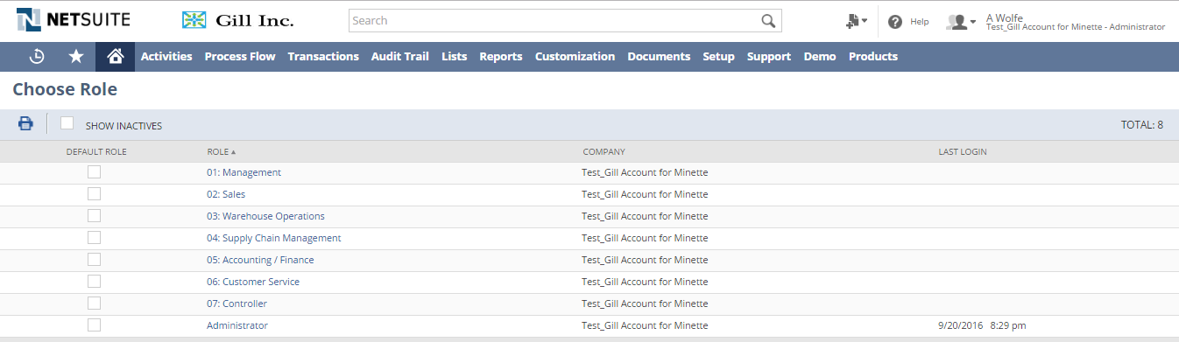

To ensure you don’t have any problems in the future and for ease of navigating. Please set the default role to administrator of the account, by selecting the box next to this account in the Default role column,

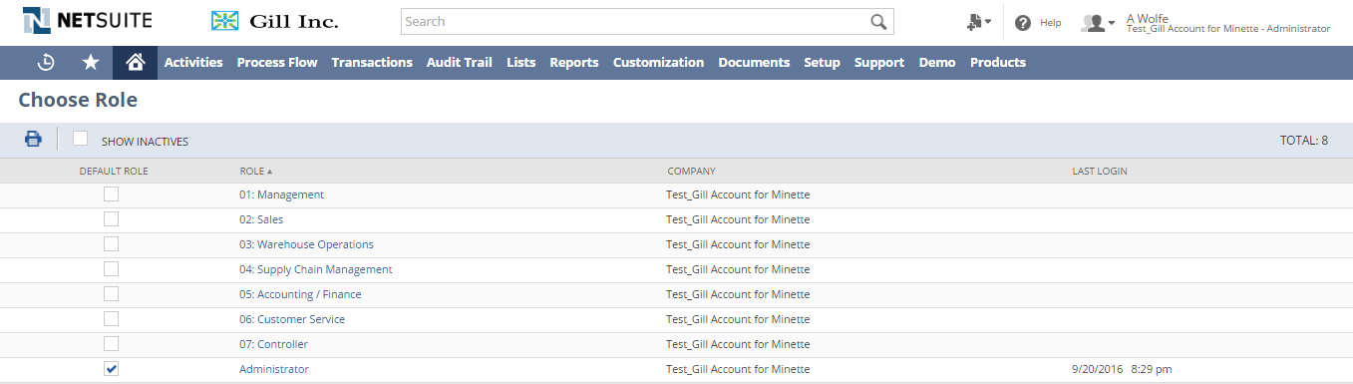

You will also notice that your default name is not your own, indicated by the name of the company/account. To change this to your name, do the following.



From the Lists Tab, move the cursor over ***Lists***, a drop down menu should appear, then float the cursor over employees, you can now select ***Employees*** just before New and Search appear.

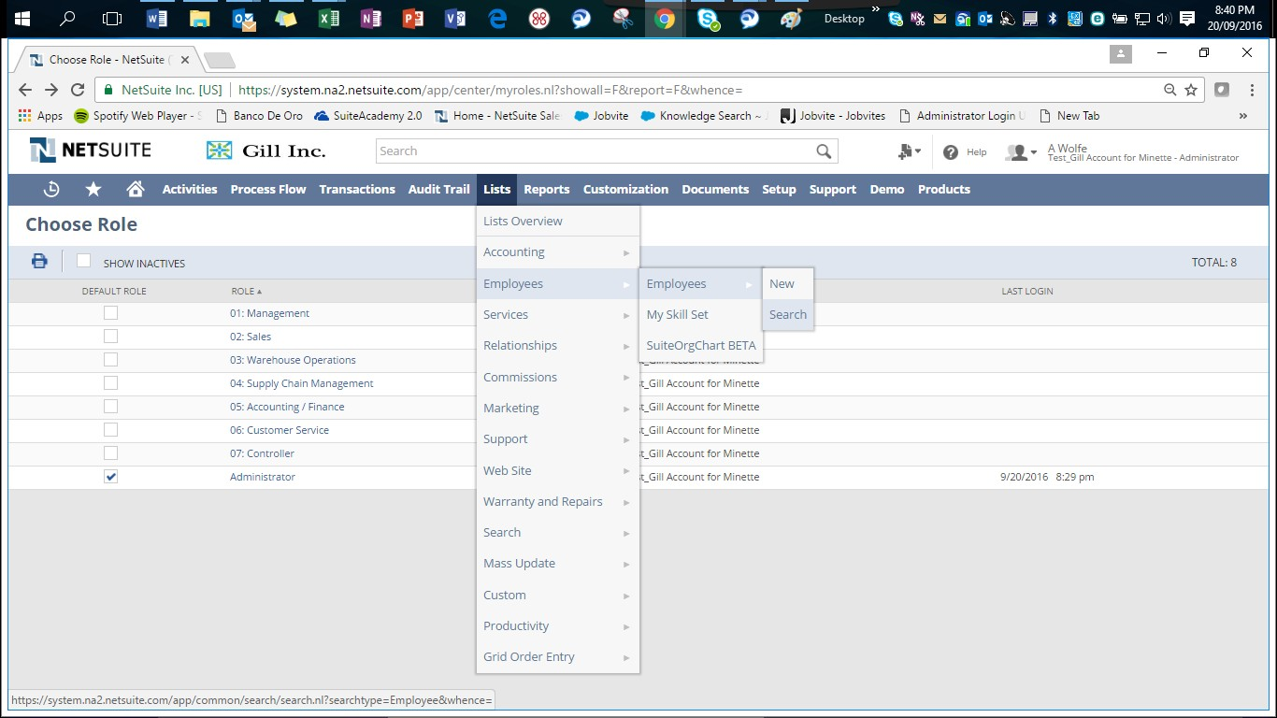

This will open a list of “employees” of this company. From here, find the default name with your corresponding email address, and select ***Edit*** on the left hand side beside this name. Again, this name will have your email beside it.

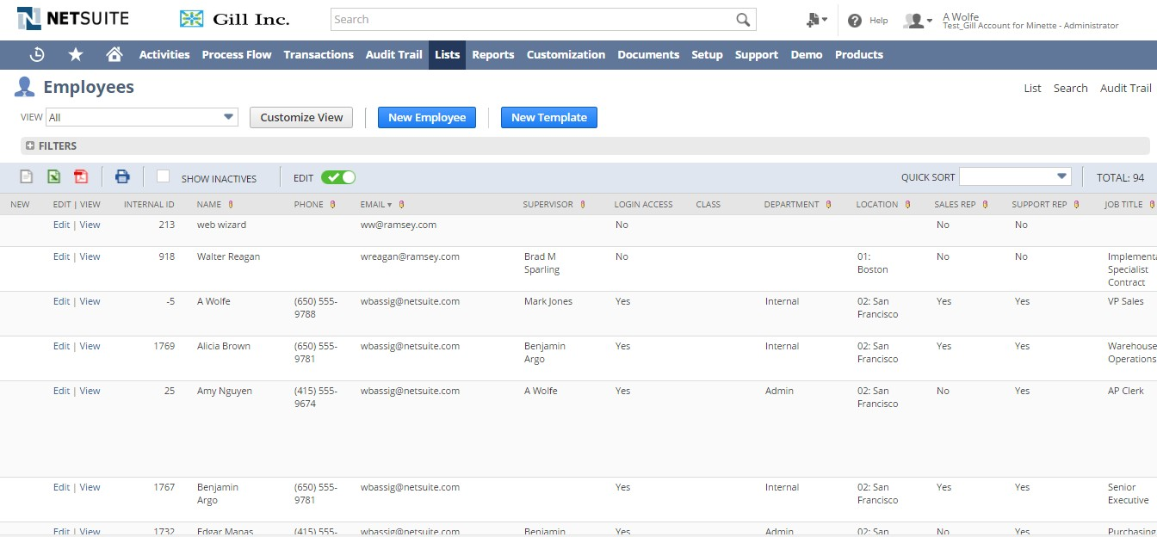

This screen is the HR record for you as an employee, in the name section, insert your first and last name, then hit ***Save***.

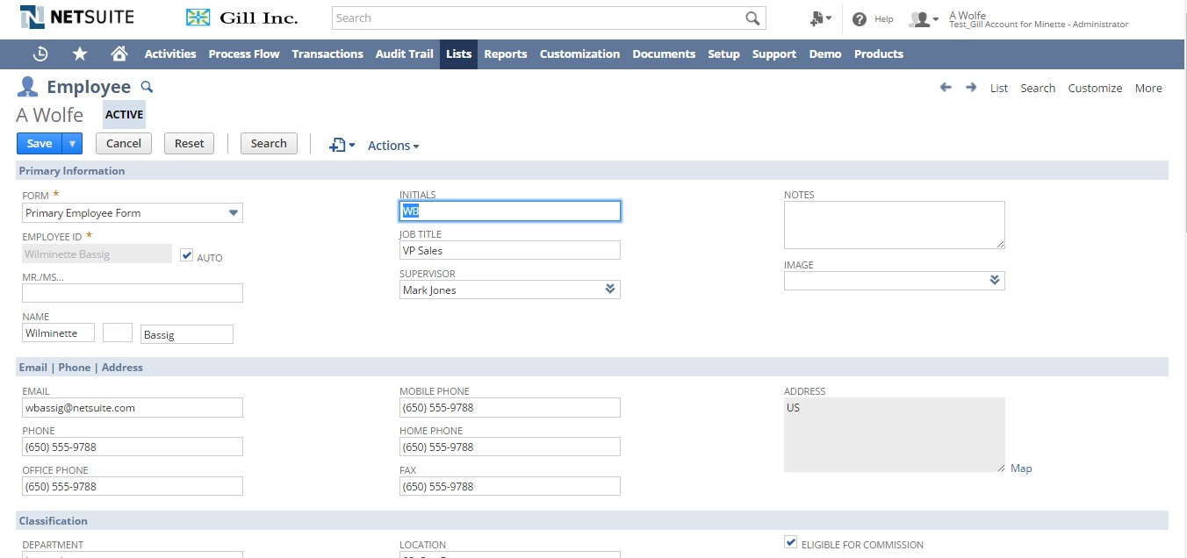

Once saved, your name should appear in the ***Role*** located in the upper corner of the site.

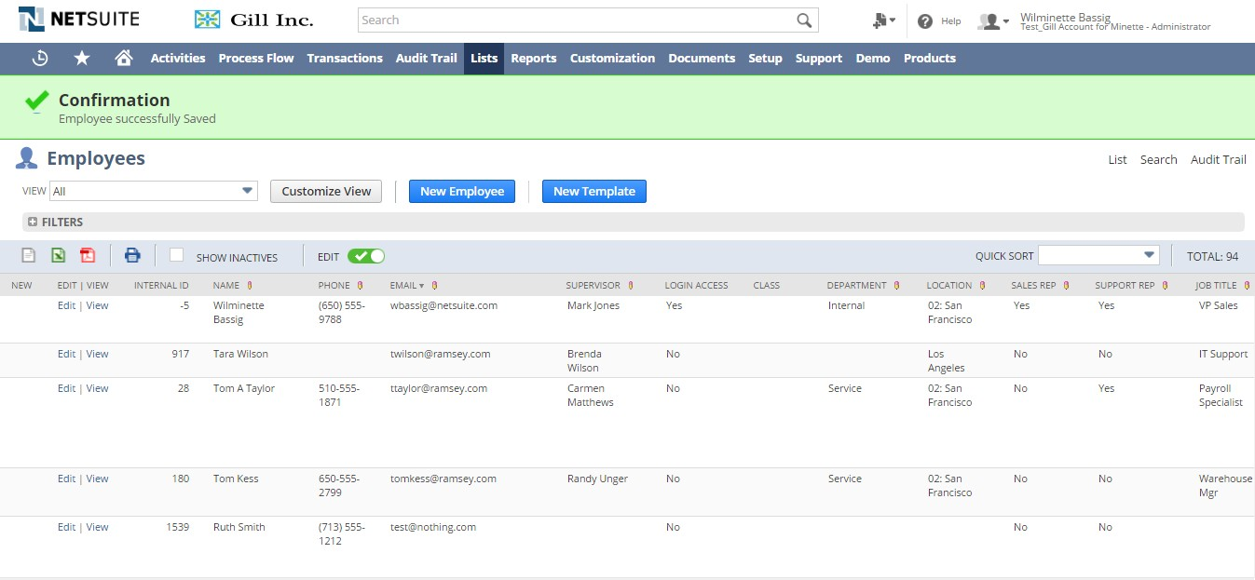

* Now change the company name and company logo to ‘your name’ and a logo of your choice (from available images) by going to Setup Tab > Company > Company Information

You might also need to setup accounting periods (for year 2016) for the processes to work properly.

1. Navigate to **Setup > Accounting > Manage Accounting Periods**
2. Click the ‘**Set up Full Year’** buton
3. Enter the following
   1. **Fiscal first month**: January
   2. **Fiscal year end**: current year
   3. **Period Format**: Calendar Months
   4. **Year in Period Name**: Ending year of period
   5. Do not check One-day Year-End Adj. period
4. **Save**